Hernandez 4th grade Bilingual Newsletter
Week of October 7, 2019
Weekly Focus  Reading: Reading Structures / Authors Message  Writing: Expository Writing  Math: Multiplication  Science: Forms of Energy  Social Studies: Native Americans | Important Information  - Please remember to read sign planners daily.  - Students are to read everyday
Spelling Words  Test Friday  - Because  - Please  - Problem  - Complete  - Friends | Upcoming Events  10/7 and 8 /2019 NO SCHOOL  10/10/2019 PTA meeting 6 p.m.  10/11/2019 Big Kahuna Party Bus Day  10/12/2019 Hawktober Fest 8 – 12  10/15/2019 Picture Day (school Uniform)  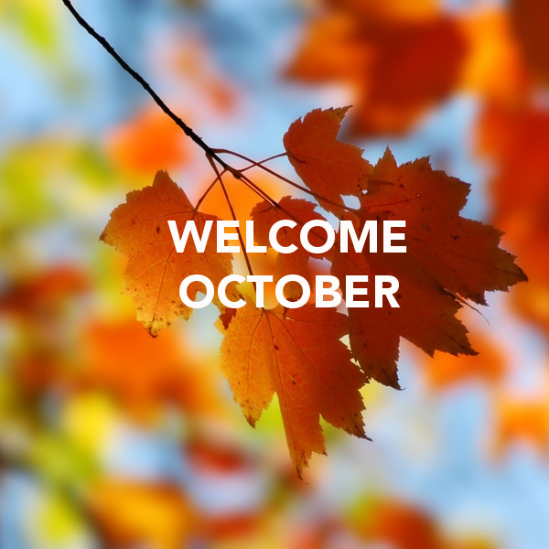
Contact Information
Griselda Hernández
email: Griselda.hernandez@redoakisd.org Phone: (972) 617-2977 ext. 2054
Remind 101: 81010 @griseldah
Conference time:
Monday – Friday 12:30 – 1:15 pm

Hernández 4th grado Carta de información
Semana de 7 de octubre 2019
Enfoque semanal  Lectura: Estructura de texto / mensaje de autor  Escritura: Escritura Narrativa  Matemáticas: multiplicación  Ciencias: Formas de energía  Estudios Sociales: Americanos nativos | Información importante  - Favor de firmar planificadores a diario.  - Alumnos deben leer todos los días.
Palabras de ortografía  Examen viernes  - Especialidad  - Advertir  - Gabinete  - Posible  - conozco | Eventos próximos  10/4/2019 Desfile homecoming 2 p.m.  10/7 and 8 /2019 NO ahí clases  10/10/2019 Junta de PTA 6 p.m.  10/11/2019 Día de Big Kahuna Party  10/12/2019 Hawktober Fest 8 – 12  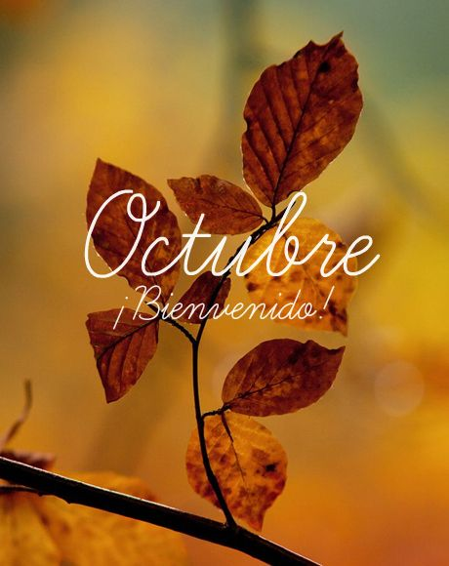  10/15/2019 Día de fotos (uniforme escolar)
Contact Information Griselda Hernández
email: Griselda.hernandez@redoakisd.org Phone: (972) 617-2977 ext. 2054
Remind 101: 81010 @griseldah
Conference time:
Monday – Friday 12:30 – 1:15 pm

